**Running the Project**

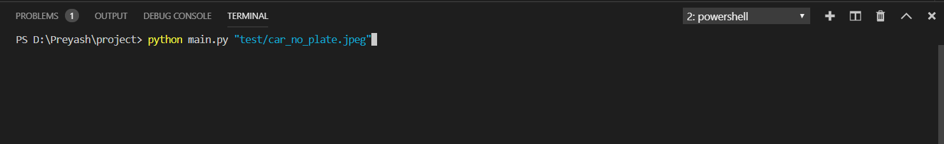

Figure 5.1.2.1 This figure shows the command used to run the project file.

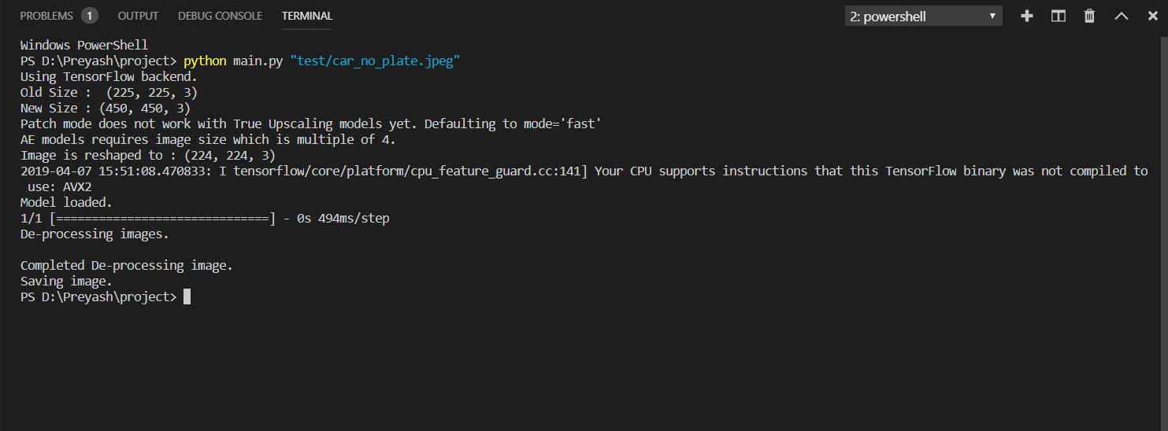

Figure 5.1.2.2 This figure shows the terminal after the processs is completed.

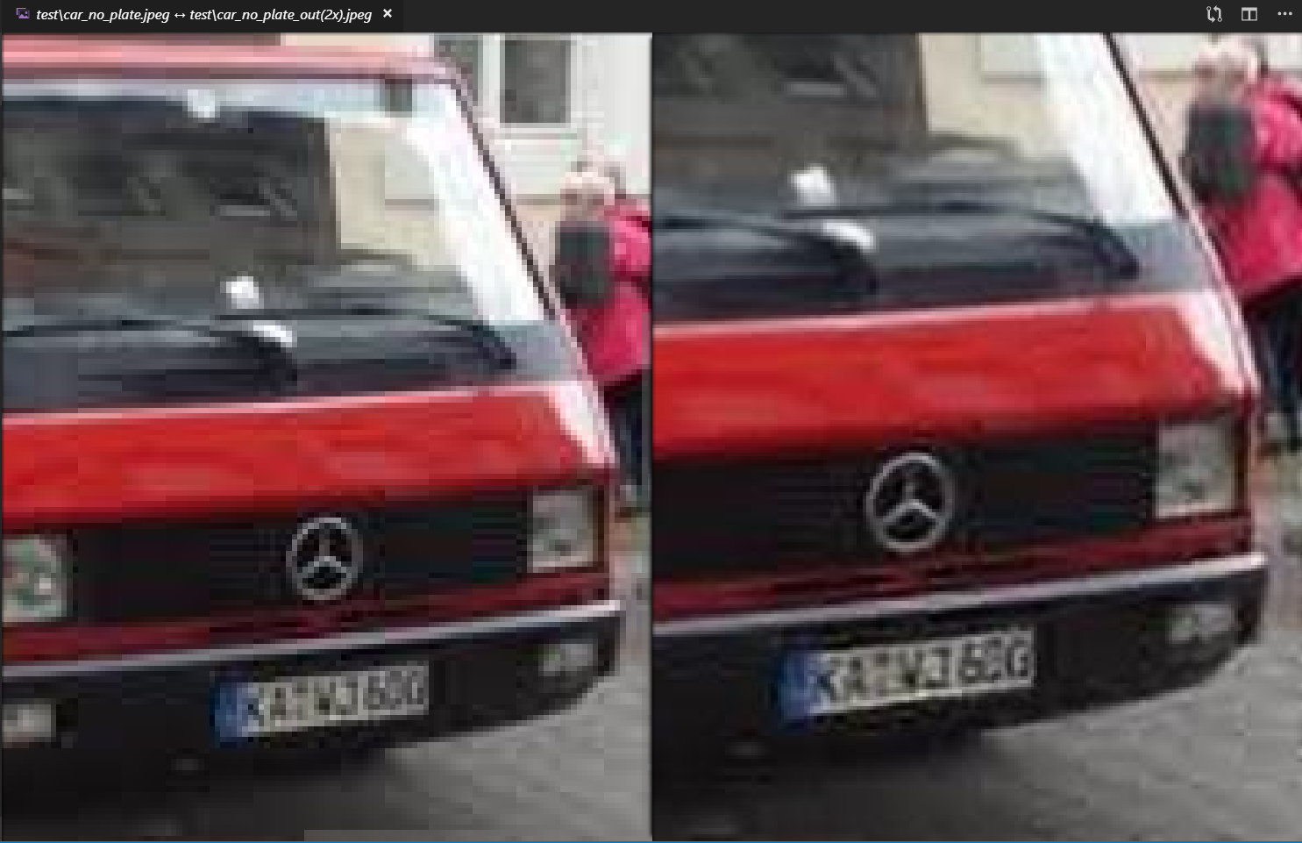Figure 5.1.2.3 This figure shows the output results comparison.(Left side is original image right side is our processed image.)

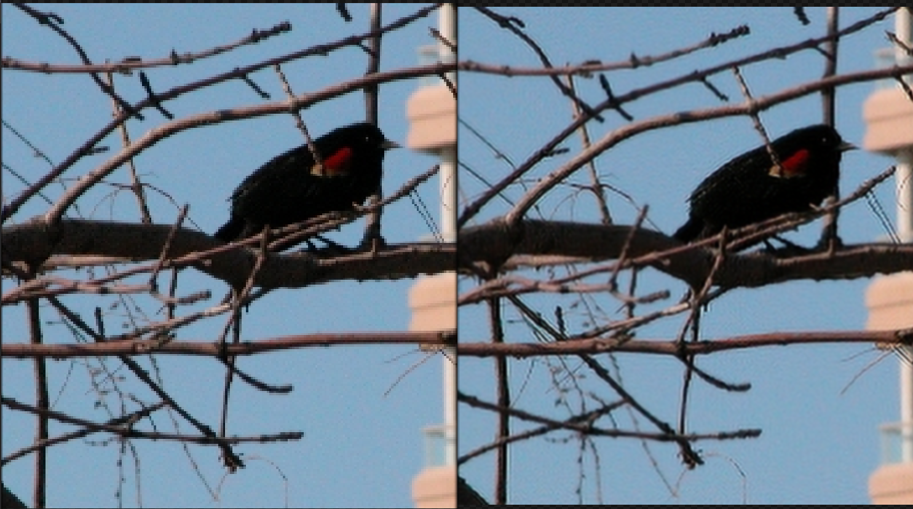Figure 5.1.2.3 This figure shows the output results comparison.(Left side is original image right side is our processed image.)

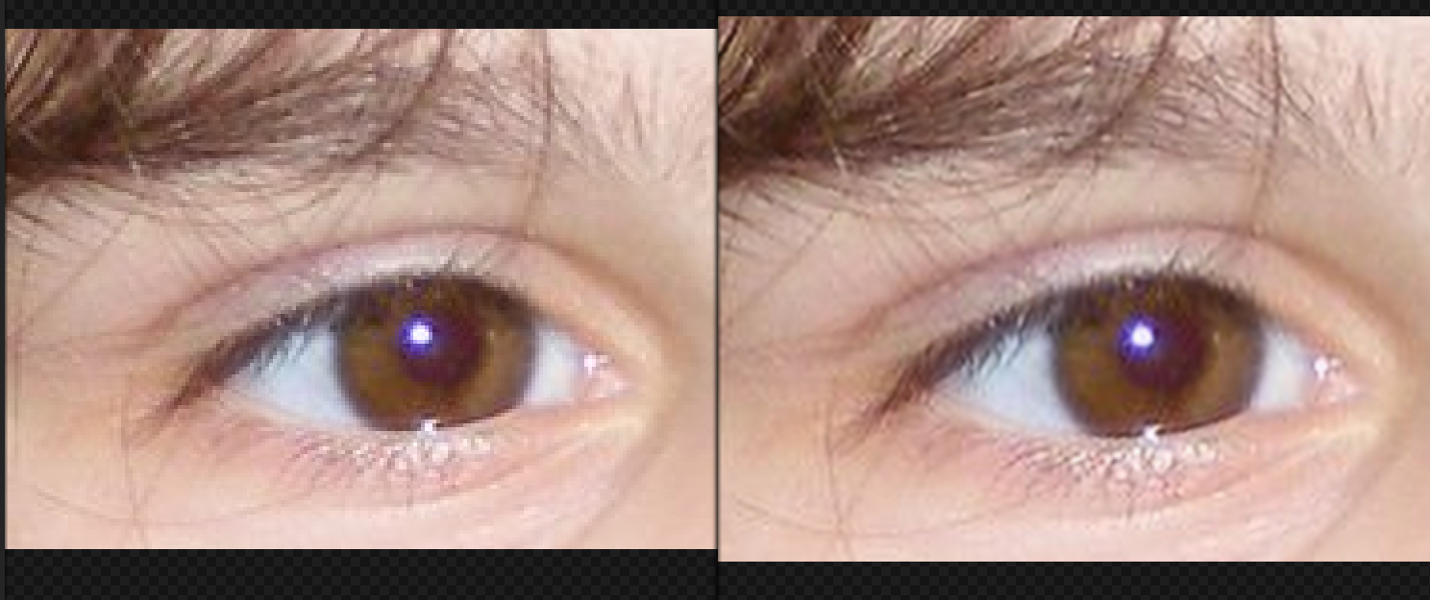

Figure 5.1.2.3 This figure shows the output results comparison.(Left side is original image right side is our processed image.)

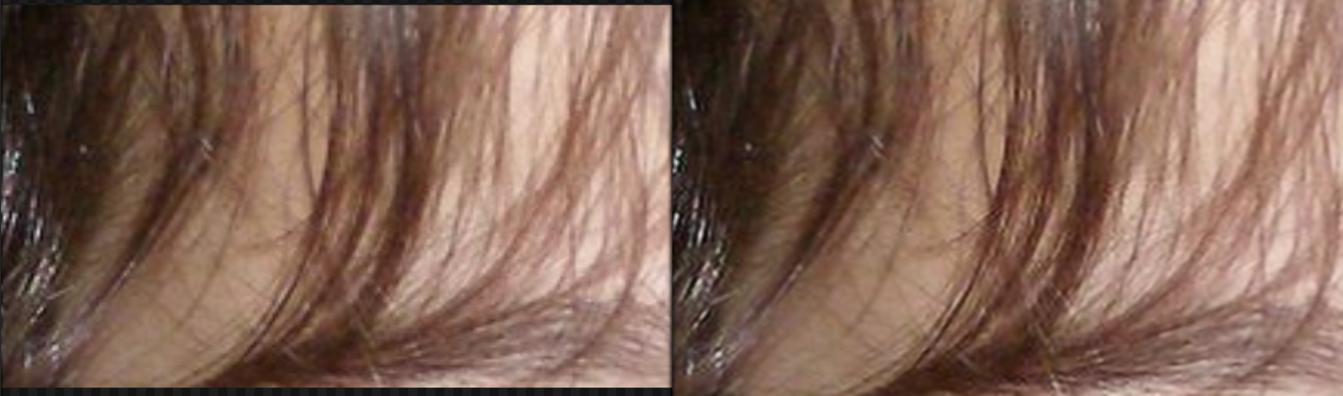Figure 5.1.2.3 This figure shows the output results comparison.(Left side is original image right side is our processed image.)